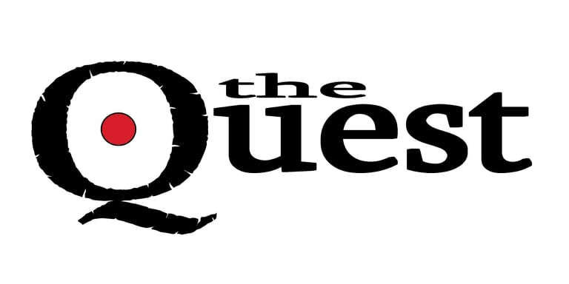
The Complete Combatant is excited to announce our 2nd Annual “The Quest”! This is going to ROCK YOUR WORLD so hang on! Each year The Complete Combatant and Modern Samurai Project team up in the month of October to bring you some of the best pistol optics training in the country.

The Quest 2023 will be hosted in North Georgia at our range in Dahlonega. This will be a 3-day event with excellent pistol optics training, sponsors, door prizes, and a VIP “Celebration of The Dot" on Saturday night. Brian Hill and Scott (Jedi) Jedlinski will each teach one day at The Quest, but the third instructor will be a special guest. We are very excited to announce that our TQ23 guest instructor is none other than AJ Zito of Practical Performance.

THE QUEST 2023 IS SOLD OUT! AS A MATTER OF FACT, IT SOLD OUT A YEAR IN ADVANCE!

We have 36 paid students PLUS 4 FREE spots for our GOLD LEVEL sponsors. Guests will train with the featured lead instructor “of the day” and the rest of The Quest’s team will be AIs and/or RSOs. That means BIG TIME “one on one” coaching from Jedi, Brian, and AJ throughout the entire 3 days! EPIC!!!

TQ23 is Friday, October 6th , Saturday, October 7th and Sunday October 8th, 2023 9am-6pm
FRIDAY: FOCUSING ON PERFORMANCE with Scott Jedlinski of Modern Samurai Project
SATURDAY: FOCUSING ON SELF DEFENSE with Brian Hill of The Complete Combatant
SUNDAY: FOCUSING ON COMPETITION with AJ Zito of Practical Performance

Would you please consider becoming one of our important sponsors? You will be involved with a “one of a kind” conference, you will be lending a helping hand to continue education and training, you will be able to reach serious shooters that are always looking to be more proficient, and you will be helping Scott, Brian, AJ and Shelley offer nothing less than the highest quality weekend! All we need is a VERBAL pledge NOW so we can start THANKING YOU on a social media platform that will hit no less than 15 thousand people per post! Nothing needs to be sent until August 15th, 2023.

TQ23 SPONSORSHIP OPPORTUNITIES:
GOLD SPONSORSHIP: $3000 ONLY 4 spots available
- 1 FREE spot to PARTICIPATE as our guest ($750 value).
- Gold sponsors also get EVERYTHING that Bronze and Silver have to offer.
- Donating a Pistol Donation Letter? You are GOLD. During a lunch break (12-2pm), you will have the opportunity to spend 45 minutes with The Quest’s guests. You can opt to spend this on the live fire range to demo your firearms or do a non-live fire presentation off the range. Our team will gladly provide the RSO, targets and course of fire. You provide the firearms and ammo.

SILVER SPONSORSHIP: $2000 ONLY 10 spots available
- Send 2 of your team to join in all the fun and OBSERVE the live fire portion for all 3 days at NO charge.
- Silver sponsors also get EVERYTHING that Bronze has to offer.

BRONZE SPONSORSHIP: $1000
- Thank you via social media and the THANK YOU SPONSORS webpage.
- Display your banner at the event. Please send me a banner (any size up to 6x6) by Sept. 1st, 2023
- Send 1 of your team to join in all the fun and OBSERVE the live fire portion for all 3 days at NO charge.

TQ23 Monetary SPONSORSHIPS: Send via check (payable to The Quest) or VENMO (thecompletecombatant). If check, please write The Quest 2023 in the note/memo sections and mail to The Complete Combatant at 2755 Porter Springs Road, Dahlonega, GA 30533.
Shelley Hill thecompletecombatant@gmail.com 404-936-6986

